Load Flow Studies

Introduction
In this section, we are looking at how can we analyze the power system in steady state in normal operation. In steady state, the state variables that describe the system doesn’t diverge from its normal operating point and remain constant. For the analysis associated with this section we assume the following

Network equations can be formed for all the network elements. From circuit analysis knowledge, the node voltage method can be used to analyze a circuit.
Example: Analyze the below circuit with node voltage method
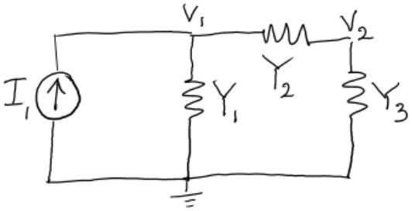
Figure 1. Example circuit for node voltage analysis

It can be seen that when the equations are written with node current injections, solving the circuit resolves into complex linear set of simultaneous equations. Node voltages can be easily solved after obtaining the inverse of the admittance matrix.
Example:
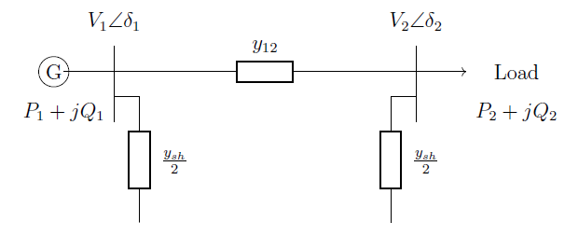
Consider the following problems:
1. $V_{2}$, $δ_{2}$ , $P_{2}$ and $Q_{2}$ are given. Find $V_{1}$, $δ_{1}$ , $P_{1}$ and $Q_{1}$.
2. $V_{1}$, $δ_{1}$ , $V_{2}$ and $δ_{2}$ are given. Find $P_{1}$, $Q_{1}$ , $P_{2}$ and $Q_{2}$.
3. $P_{2}$, $Q_{2}$ , $V_{1}$ and $δ_{1}$ are given. Find $V_{2}$, $δ_{2}$ , $P_{1}$ and $Q_{1}$.
However, in power system usually the node active power and reactive power injections are specified, rather than current injections. Thus the resulting equations based on power are defined as “power flow equations” or “load flow equations”. These two terms are used interchangeably in the literature.
Apparent power $S=VI^{*}$, which is a nonlinear equation. This makes the above power flow equations non-linear. These non-linear equations cannot be easily solved as algebraic equations and require iterative solution methods.
Solving for the power flow of a network gives the node (or bus) voltages and angles, active and reactive power flow in branches (transmission lines and transformers). These information is essential for
- Power system planning and design
- Planning
- Operation
- Economic scheduling
- Contingency studies
- Calculate initial conditions for transient stability and Electromagnetic transient simulation studies.
This section is aiming to cover the following sections
- Mathematical formulation of load flow studies.
- Different solution techniques to solve the non-linear load flow equations

Mathematical Formulation

Bus Admittance Matrix
Let us expand the node voltage analysis in previous section to a simple power system with two generators (voltage source behind a reactance) and four branches made with reactance (resistance and shunt capacitance are neglected for simplicity).
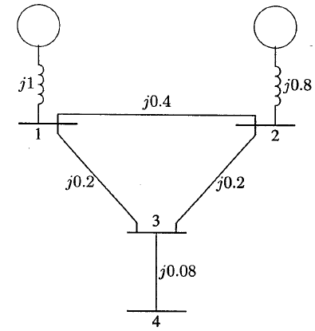
Figure 2. Example simple power system with impedances.
Node voltage method is based on Kirchoff’s current law → easy to analyze with admittances rather than impedance
$$y_{ij}=\frac{1}{z_{ij}}=\frac{1}{r_{ij}+jx_{ij}}$$
Redraw circuit with admittances and voltage sources by their respective Norton equivalent current sources
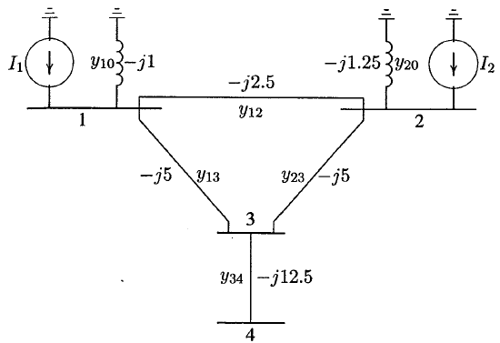
Figure 3. Redrawn circuit with admittance and current sources.
Applying KCL for each node and re arranging the terms as done in previous section
Arranging in matrix form

In the above equation $I_{bus}$ is the vector of bus current injections (positive if current is injected to the bus) and is complex in general. $V_{bus}$ is the bus voltage vector and is complex in general. $Y_{bus}$ is the bus admittance matrix and its elements are generally denoted as $Y_{ij}$ where $i$ is the row number and $j$ is the column number. Diagonal elements of $Y_{bus}$ are known as driving point admittance or self-admittance and is the addition of all the admittances connected to the node of interest.
$$Y_{ii}=\sum_{j=0}^{n}{y_{ij}} j≠ⅈ$$
Off diagonal elements equal to the negative admittances between the two nodes (busses) represented by row and column numbers. This element is known as mutual admittance or transfer admittance.
$$Y_{ij}=Y_{ji}=-y_{ij}$$
Solution of the voltages
$$V_{bus}=Y_{bus}^{-1}I_{bus}$$
Inverse of admittance matrix $Y_{bus}^{-1}$ is bus impedance matrix. If the admittance matrix is defined with a reference bus (slack bus which is described later) the matrix is non-singular. Otherwise the matrix is singular.
Admittance matrix is symmetrical around the leading diagonal. Thus only requires to store information on half of the matrix. This is important when considering real size grids containing thousands of busses. (Typical power system analysis of North American eastern Interconnection is modelled with around 70,000-80,000 busses).
Typically admittance matrix is sparse. Usually correctly ordered triangular decomposition methods are used to calculate the inverse of such large sparse matrices gaining computational speed (students are advised to read on the mathematics for more information).

Load Flow/Power Flow Equation
Load flow solution solves for bus voltages (magnitude and angle) and active and reactive power flows in the branches. Four quantities are associated with each bus
- Voltage magnitude $\left|V\right|$
- Voltage angle $δ$
- Active (real) power $P$
- Reactive power $Q$
Busses of the power system are categorized into three main types based on how they are operated
- Slack Bus/ Swing Bus

- PV busses/ Generator busses / Regulated busses

- Load busses/ PQ busses

Consider a bus in a network as shown below.
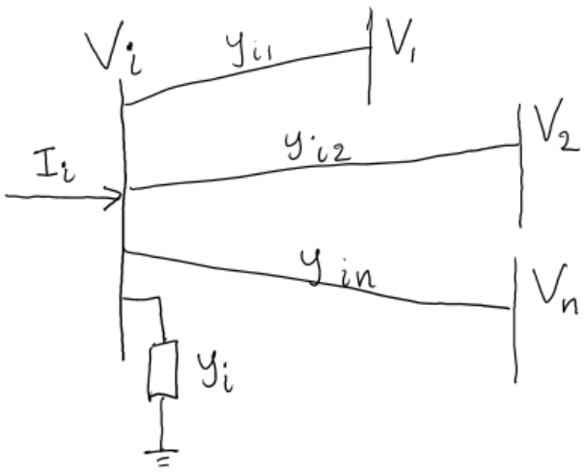
Figure 4. Bus i of the power system connected to n number of busses.
- Obtain an expression for bus current injection.
- Write an expression for apparent power using voltage and current.
- Substitute for the current.

Thus we observe the equation is non-linear and we have to resolve for iterative methods to solve the equation. In the next section we will first look at few non-linear algebraic equation solution methods in general. Then we could apply the iterative methods to solve for the load flow equations.

Solving Non-linear Algebraic Equations
Different iterative calculation methods are used to solve non-linear algebraic equations.
- Gauss-Seidel Method
- Newton-Raphson Method
- Quasi-Newton Methods
First, the general concept of these methods are discussed for one-dimensional and n-dimensional equations. Then they are extended to solve the non-linear equations in in power flow equations.

Gauss-Seidel Method
Method is also known as successive displacement. Consider the solution of the following non-linear equation.
$$f\left(x\right)=0$$
The equation can be re-arranged as follows
$$x=g\left(x\right)$$
Lets say the initial estimate of $x$ is $x^{(k)}$. Then we can form the following iterative sequence
$$x^{\left(k+1\right)}=g\left(x^{\left(k\right)}\right)$$
A solution is obtained when the difference between successive iterations are less than a specified accuracy
$$\left|x^{\left(k+1\right)}-x^{\left(k\right)}\right|≤ϵ$$
Example: Use Gauss-Seidel method to find the root of the following equation.
$$f\left(x\right)=x^{3}-6x^{2}+9x-4=0$$
Solution:
Re arrange the equation as follows
$$x=-\frac{1}{9}x^{3}+\frac{6}{9}x^{2}+\frac{4}{9}$$
$$x=g\left(x\right)$$
We can plot $x$ and $g\left(x\right)$ over a range of $x$ values as follows. The solution will be the $x$ values where the two curves intersect.
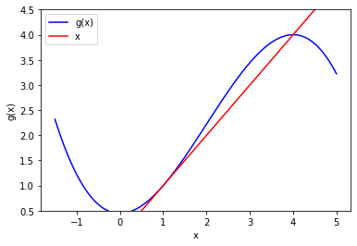
The figure shows that there are roots existing at $x=1$, and $x=4$.
Ex: Calculate three iterations of the Gauss-Siedel algorithm

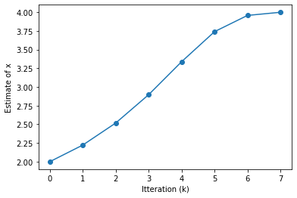
Figure 5. Progression of estimate of x in Gauss-Seidel algorithm.
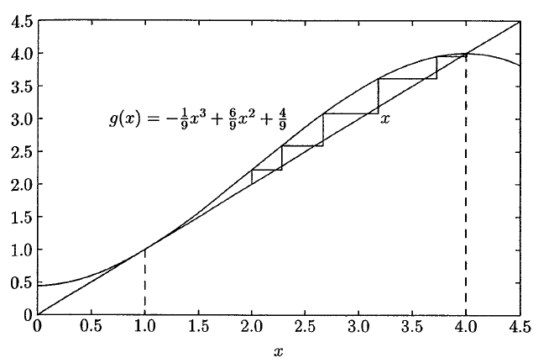
Figure 6. Process of solution of Gauss-Seidel method
Considerable number of iterations were taken to reach the solution. The convergence of the solution is not guaranteed as well.
To make the convergence of the solution faster, an acceleration factor ($α$) can be introduced to the Gauss-Seidel algorithm.
$$x^{\left(k+1\right)}=x^{\left(k\right)}+α\left[g\left(x^{\left(k\right)}\right)-x^{\left(k\right)}\right]$$
In a system of $n$ non-linear equations with $n$ variables
$$f_{1}\left(x_{1},x_{2},…,x_{n}\right)=c_{1}$$
$$f_{2}\left(x_{1},x_{2},…,x_{n}\right)=c_{2}$$
$$⋯$$
$$f_{n}\left(x_{1},x_{2},…,x_{n}\right)=c_{n}$$
Rearranged as follows
$$x_{1}=c_{1}+g_{1}\left(x_{1},x_{2},…,x_{n}\right)$$
$$x_{2}=c_{2}+g_{2}\left(x_{1},x_{2},…,x_{n}\right)$$
$$⋯$$
$$x_{n}=c_{n}+g_{n}\left(x_{1},x_{2},…,x_{n}\right)$$
The algorithm is initiated with initial estimates for the $n$ variables. ($x_{1}^{(0)},x_{2}^{(0)},…,x_{n}^{(0)}$). The initial estimates are used in the first non-linear equation and the calculated variable from first equation is used in subsequent equations. This is carried out for all the non-linear equations. The accuracy of each variable is tested for all variables in each iteration. The algorithm is converged when all variables successive calculated values are within the specified tolerance.

Newton-Raphson Method
This is the most used algorithm for solving non-linear algebraic equations. The method relies on successive approximation based on initial estimate.
Consider the one dimensional equation
$$f\left(x\right)=c$$
If $x^{(0)}$ is the initial estimate and $∆x^{(0)}$ a small perturbation from the solution
$$f\left(x^{(0)}+ ∆x^{(0)}\right)=c$$
Expand the left hand by Taylor’s series expansion
$$f\left(x^{\left(0\right)}\right)+{\left(\frac{ⅆf}{ⅆx}\right)}^{\left(0\right)}Δx^{\left(0\right)}+\frac{1}{2!}{\left(\frac{ⅆ^{2}f}{ⅆx^{2}}\right)}^{\left(0\right)}{\left(Δx^{\left(0\right)}\right)}^{2}+⋯=c$$
It can be assumed that the perturbation is very small making the higher order terms negligible
$${\left(\frac{ⅆf}{ⅆx}\right)}^{\left(0\right)}Δx^{\left(0\right)}≈c-f\left(x^{\left(0\right)}\right)=Δc^{(0)}$$
The second approximation is derived by adding the $Δx^{\left(0\right)}$ term to the initial estimate
$$x^{\left(1\right)}=x^{\left(0\right)}+\frac{Δc^{\left(0\right)}}{{\left(\frac{ⅆf}{ⅆx}\right)}^{\left(0\right)}}$$
This procedure can be iteratively used to approximate the solution, and thus Newton-Raphson algorithm is developed. For generally the k^{th} iteration:
$$Δc^{\left(k\right)}=c-f\left(x^{\left(k\right)}\right)$$
$$Δx^{\left(k\right)}=\frac{Δc^{\left(k\right)}}{{\left(\frac{ⅆf}{ⅆx}\right)}^{\left(k\right)}}$$
$$x^{\left(k+1\right)}=x^{\left(k\right)}+Δx^{\left(k\right)}$$
This can be rearranged as
$$Δc^{\left(k\right)}=j^{\left(k\right)}Δx^{\left(k\right)}$$
Where
$$j^{\left(k\right)}={\left(\frac{ⅆf}{ⅆx}\right)}^{\left(k\right)}$$
Newton-Raphson method effectively construct the tangent at the first estimate value, and find the intersection of tangent line with $c$ curve. The new estimate for $x$ is obtained at the intersecting point.
Example: Use Newton-Raphson method to find the root of the following equation.
$$f\left(x\right)=x^{3}-6x^{2}+9x-4=0$$
Solution:
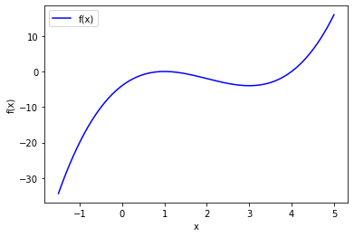
Figure 7. Plot of f(x)

Next following results
Iteration $(k)$ | $$Δc^{\left(k\right)}$$ | $${\left(\frac{ⅆf}{ⅆx}\right)}^{\left(k\right)}$$ | $$Δx^{\left(k\right)}$$ | $$x^{\left(k+1\right)}$$
1 | -13.443 | 22.037 | -0.610 | 4.278
2 | -2.998 | 12.579 | -0.238 | 4.040
3 | -0.374 | 9.491 | -0.039 | 4.001

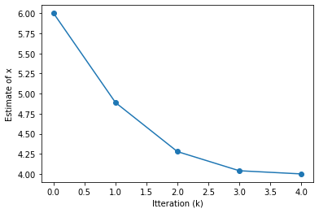
Figure 8. Progression of the estimates of x in Newton Raphson method.
It can be seen that the convergence is faster than Gauss-Seidel method. It can be seen that the iterative methods can converge at a different root, if the initial estimate is far from the expected root (solution).
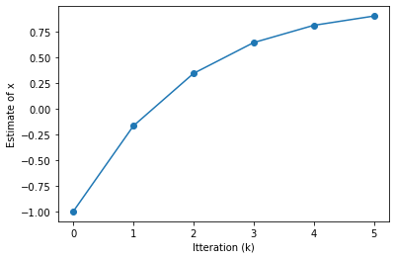
Figure 9. Progression of Newton-Raphson method with initial estimate at -1.0.
For an $n$ dimensional set of equations with $n$ variables, where perturbations are expanded using Taylor’s series and neglecting higher order terms as done for one-dimensional derivation
$${\left(f_{1}\right)}^{\left(0\right)}+{\left(\frac{∂f_{1}}{∂x_{1}}\right)}^{\left(0\right)}Δx_{1}^{\left(0\right)}+{\left(\frac{∂f_{1}}{∂x_{2}}\right)}^{\left(0\right)}Δx_{2}^{\left(0\right)}+…+{\left(\frac{∂f_{1}}{∂x_{n}}\right)}^{\left(0\right)}Δx_{n}^{\left(0\right)}=c_{1}$$
$${\left(f_{2}\right)}^{\left(0\right)}+{\left(\frac{∂f_{2}}{∂x_{1}}\right)}^{\left(0\right)}Δx_{1}^{\left(0\right)}+{\left(\frac{∂f_{2}}{∂x_{2}}\right)}^{\left(0\right)}Δx_{2}^{\left(0\right)}+…+{\left(\frac{∂f_{2}}{∂x_{n}}\right)}^{\left(0\right)}Δx_{n}^{\left(0\right)}=c_{2}$$
$$⋯$$
$${\left(f_{n}\right)}^{\left(0\right)}+{\left(\frac{∂f_{n}}{∂x_{1}}\right)}^{\left(0\right)}Δx_{1}^{\left(0\right)}+{\left(\frac{∂f_{n}}{∂x_{2}}\right)}^{\left(0\right)}Δx_{2}^{\left(0\right)}+…+{\left(\frac{∂f_{n}}{∂x_{n}}\right)}^{\left(0\right)}Δx_{n}^{\left(0\right)}=c_{2}$$
Or in matrix form
$$\left[\begin{matrix}c_{1}-{\left(f_{1}\right)}^{\left(0\right)} \\ c_{2}-{\left(f_{2}\right)}^{\left(0\right)} \\ ⋮ \\ c_{n}-{\left(f_{n}\right)}^{\left(0\right)}\end{matrix}\right]=\left[\begin{matrix}{\left(\frac{∂f_{1}}{∂x_{1}}\right)}^{\left(0\right)} & {\left(\frac{∂f_{1}}{∂x_{2}}\right)}^{\left(0\right)} & ⋯ & {\left(\frac{∂f_{1}}{∂x_{n}}\right)}^{\left(0\right)} \\ {\left(\frac{∂f_{2}}{∂x_{1}}\right)}^{\left(0\right)} & {\left(\frac{∂f_{2}}{∂x_{2}}\right)}^{\left(0\right)} & ⋯ & {\left(\frac{∂f_{2}}{∂x_{n}}\right)}^{\left(0\right)} \\ ⋮ & ⋮ & ⋱ & ⋮ \\ {\left(\frac{∂f_{n}}{∂x_{1}}\right)}^{\left(0\right)} & {\left(\frac{∂f_{n}}{∂x_{2}}\right)}^{\left(0\right)} & ⋯ & {\left(\frac{∂f_{n}}{∂x_{n}}\right)}^{\left(0\right)}\end{matrix}\right]\left[\begin{matrix}Δx_{1}^{\left(0\right)} \\ Δx_{2}^{\left(0\right)} \\ ⋮ \\ Δx_{n}^{\left(0\right)}\end{matrix}\right]$$
Or in short matrix symbols it can be re-written
$$ΔC^{\left(k\right)}=J^{\left(k\right)}ΔX^{\left(k\right)}$$
Or
$$ΔX^{\left(k\right)}={\left[J^{\left(k\right)}\right]}^{-1}ΔC^{\left(k\right)}$$
Newton-Raphson algorithm for the next estimate becomes
$$X^{\left(k+1\right)}=X^{\left(k\right)}+ΔX^{\left(k\right)}$$
$J^{\left(k\right)}$ is known as the Jacobian matrix. This matrix is formulated with partial derivatives of the set of equations at the estimated value. During the Newton-Raphson calculation, it is assumed that the Jacobian matrix is non-singular.

Using Gauss-Seidel Algorithm to Solve the Load Flow Equation
The load flow equation for voltage modified for Gauss-Seidel algorithm is as follows
$$V_{i}^{\left(k+1\right)}=\frac{\frac{P_{i}^{sch}-jQ_{i}^{sch}}{V_{i}^{*(k)}}+∑y_{ij}V_{j}^{\left(k\right)}}{∑y_{ij}} j≠i$$
The load flow equations were developed assuming currents are injecting into the bus. Therefore, for loads active $P_{i}^{sch}$ and reactive (inductive reactive) $Q_{i}^{sch}$ power flows will be negative. For generators which inject active and reactive power into the bus $P_{i}^{sch}$ and $Q_{i}^{sch}$ will be positive.
$$P_{i}^{\left(k+1\right)}=\operatorname{Re}\left\{V_{i}^{*(k)}\left[V_{i}^{\left(k\right)}\sum_{j=0}^{n}{y_{ij}}-\sum_{j=1}^{n}{y_{ij}V_{j}^{\left(k\right)}}\right]\right\} j≠i$$
$$Q_{i}^{\left(k+1\right)}=-Im\left\{V_{i}^{*(k)}\left[V_{i}^{\left(k\right)}\sum_{j=0}^{n}{y_{ij}}-\sum_{j=1}^{n}{y_{ij}V_{j}^{\left(k\right)}}\right]\right\} j≠i$$
Representing the equations with elements in $Y_{bus}$ bus admittance matrix
Voltage equation:

Active power equation:

Reactive power equation:

Solving for load busses/PQ busses
For PQ busses, both $P_{i}^{sch}$ and $Q_{i}^{sch}$ are known and voltage magnitude and phase angle are unknown. Thus the above voltage equation is used to solve for the real and imaginary components of the voltage. Thus for each PQ bus, two equations are solved (real and imaginary).

Solving for generator busses/PV busses
Generator busses have $P_{i}^{sch}$ and $\left|V_{i}\right|$ are specified. The initial estimate of the voltages are used to first evaluate the reactive power schedule $Q_{i}^{sch}$ at the bus using the above reactive power equation. Then a voltage estimate for the bus is calculated using the voltage equation.
$$V_{i_{,est}}^{k+1}=$$
However the voltage magnitude of the PV bus is constant and specified in the problem. Thus the real part of the final voltage estimate is obtained such that

$$V_{ⅈ}^{\left(k+1\right)}=$$

For a power system in normal operating region, the bus voltages are in the neighborhood of 1.0 pu or closer to the slack bus. Bus voltage magnitude and angles change depending on the active and reactive power flow through the system. Thus a initial estimate of $1.0+j0.0 pu$ is satisfactory for most of the power systems.
In Gauss-Seidel algorithm, the updated voltages replace the previous values for subsequent equations.
The algorithm can be made faster by using an appropriate acceleration factor as shown below.
$$V_{i}^{\left(k+1\right)}=V_{i}^{\left(k\right)}+α\left(V_{ⅈ,ⅇst}^{\left(k\right)}-V_{i}^{\left(k\right)}\right)$$ The iterative process is carried out until the difference between successive iterations in both real and imaginary components are within a specified accuracy $ϵ$. In order to get reasonable power mismatch, very tight tolerances need to be specified (0.00001-0.00005 pu)
$$\left|\operatorname{Re}\left[V_{ⅈ}^{\left(k+1\right)}\right]-\operatorname{Re}\left[V_{ⅈ}^{\left(k\right)}\right]\right|≤ϵ$$
$$\left|\operatorname{Im}\left[V_{ⅈ}^{\left(k+1\right)}\right]-\operatorname{Im}\left[V_{ⅈ}^{\left(k\right)}\right]\right|≤ϵ$$

Using Newton-Raphson Algorithm to Solve the Load Flow Equation
Ex. Obtain an expression for active power and reactive power injected into a bus $i$ in a $n$ bus system.

For PQ busses, there will be two equations for both active and reactive power. For PV busses, there will be one equation for active power (since reactive power is not set)
Taking bus number 1 as the slack bus and expanding the above two equations using Taylor’s series expansion around the initial estimate, and neglecting higher order terms
$$\left[\begin{matrix}∆P_{2}^{(k)} \\ ⋮ \\ ∆P_{n}^{(k)} \\ ∆Q_{2}^{(k)} \\ ⋮ \\ ∆Q_{n}^{(k)}\end{matrix}\right]=\left[\begin{matrix}{\frac{∂P_{2}}{∂δ_{2}}}^{(k)} & ⋯ & {\frac{∂P_{2}}{∂δ_{n}}}^{(k)} & {\frac{∂P_{2}}{∂\left|V_{2}\right|}}^{(k)} & ⋯ & {\frac{∂P_{2}}{∂\left|V_{n}\right|}}^{(k)} \\ ⋮ & ⋱ & ⋮ & ⋮ & ⋱ & ⋮ \\ {\frac{∂P_{n}}{∂δ_{2}}}^{(k)} & ⋯ & {\frac{∂P_{n}}{∂δ_{n}}}^{(k)} & {\frac{∂P_{n}}{∂\left|V_{2}\right|}}^{(k)} & ⋯ & {\frac{∂P_{n}}{∂\left|V_{n}\right|}}^{(k)} \\ {\frac{∂Q_{2}}{∂δ_{2}}}^{(k)} & ⋯ & {\frac{∂Q_{2}}{∂δ_{n}}}^{(k)} & {\frac{∂Q_{2}}{∂\left|V_{2}\right|}}^{(k)} & ⋯ & {\frac{∂Q_{2}}{∂\left|V_{n}\right|}}^{(k)} \\ ⋮ & ⋱ & ⋮ & ⋮ & ⋱ & ⋮ \\ {\frac{∂Q_{n}}{∂δ_{2}}}^{(k)} & ⋯ & {\frac{∂Q_{n}}{∂δ_{n}}}^{(k)} & {\frac{∂Q_{n}}{∂\left|V_{2}\right|}}^{(k)} & ⋯ & {\frac{∂Q_{n}}{∂\left|V_{n}\right|}}^{(k)}\end{matrix}\right]\left[\begin{matrix}∆δ_{2}^{(k)} \\ ⋮ \\ ∆δ_{n}^{(k)} \\ ∆\left|V_{2}^{(k)}\right| \\ ⋮ \\ ∆\left|V_{n}^{(k)}\right|\end{matrix}\right]$$
The Jacobian matrix gives relationships between small changes in voltage angle and voltage magnitude to small changes in active and reactive power.
$$\left[\begin{matrix}ΔP \\ ΔQ\end{matrix}\right]=\left[\begin{matrix}J_{1} & J_{2} \\ J_{3} & J_{4}\end{matrix}\right]\left[\begin{matrix}Δδ \\ Δ\left|V\right|\end{matrix}\right]$$

Order of the Jacobian matrix
For a power system with $n$ busses, there is one slack bus
For PQ busses, both active power and reactive power constraints exists.
For PV busses, the bus voltage magnitude is controlled and thus equations involving $∆Q$ and $∆V$ and the corresponding columns are eliminated.
Thus there will be $n-1$ active power constraint equations and if there are $m$ number of PV busses, $n-1-m$ reactive power constraint equations will exist.
$J_{1}$ matrix is of order $\left(n-1\right)×\left(n-1\right)$
$J_{2}$ matrix is of order $\left(n-1\right)×\left(n-1-m\right)$
$J_{3}$ matrix is of order $\left(n-1-m\right)×\left(n-1\right)$
$J_{4}$ matrix is of order $\left(n-1-m\right)×\left(n-1-m\right)$
Thus the order of the Jacobian is $\left(2n-2-m\right)×\left(2n-2-m\right)$

Elements of the Jacobian matrix
For completion, the element of the Jacobian matrix is presented here. It is advised to derive these expressions on your own for familiarity.
$J_{1}$ matrix
Diagonal elements $\frac{∂P_{i}}{∂δ_{i}}=\sum_{j≠i}{\left|V_{i}\left\|V_{j}\right\|Y_{ij}\right|\sin\left(θ_{ij}-δ_{i}+δ_{j}\right)}$
Off-diagonal elements $\frac{∂P_{i}}{∂δ_{j}}=-\left|V_{i}\left\|V_{j}\right\|Y_{ij}\right|\sin\left(θ_{ij}-δ_{i}+δ_{j}\right) j≠i$
$J_{2}$ matrix
Diagonal elements $\frac{∂P_{i}}{∂\left|V_{i}\right|}=2\left|V_{i}\right|\left|Y_{ii}\right|\cos{θ_{ii}}+\sum_{j≠i}{\left|V_{j}\right|\left|Y_{ij}\right|\cos\left(θ_{ij}-δ_{i}+δ_{j}\right)}$
Off-diagonal elements $\frac{∂P_{i}}{∂\left|V_{j}\right|}=\left|V_{i}\right|\left|Y_{ij}\right|\cos\left(θ_{ij}-δ_{i}+δ_{j}\right) j≠ⅈ$
$J_{3}$ matrix
Diagonal elements $\frac{∂Q_{i}}{∂δ_{i}}=\sum_{j≠i}{\left|V_{i}\left\|V_{j}\right\|Y_{ij}\right|\cos\left(θ_{ij}-δ_{i}+δ_{j}\right)}$
Off-diagonal elements $\frac{∂Q_{i}}{∂δ_{j}}=-\left|V_{i}\left\|V_{j}\right\|Y_{ij}\right|\cos\left(θ_{ij}-δ_{i}+δ_{j}\right) j≠ⅈ$
$J_{4}$ matrix
Diagonal elements $\frac{∂Q_{i}}{∂\left|V_{i}\right|}=-2\left|V_{i}\right|\left|Y_{ii}\right|\sin{θ_{ii}}-\sum_{j≠i}{\left|V_{j}\right|\left|Y_{ij}\right|\sin\left(θ_{ij}-δ_{i}+δ_{j}\right)}$
Off-diagonal elements $\frac{∂Q_{i}}{∂\left|V_{j}\right|}=-\left|V_{i}\right|\left|Y_{ij}\right|\sin\left(θ_{ij}-δ_{i}+δ_{j}\right) j≠ⅈ$

Power residuals
Difference between the scheduled and calculated values
$$ΔP_{i}^{\left(k\right)}=P_{i}^{sch}-P_{i}^{\left(k\right)}$$
$$ΔQ_{i}^{\left(k\right)}=Q_{i}^{sch}-Q_{i}^{\left(k\right)}$$
New estimates of voltages
$$δ_{i}^{\left(k+1\right)}=δ_{i}^{\left(k\right)}+Δδ_{i}^{\left(k\right)}$$
$$\left|V_{i}^{\left(k+1\right)}\right|=\left|V_{i}^{\left(k\right)}\right|+Δ\left|V_{i}^{\left(k\right)}\right|$$

Procedure of conducting load flow calculation using Newton-Raphson method
Step 1
- PQ bus, $P_{i}^{sch}$ and $Q_{i}^{sch}$ are specified. Initial voltage magnitudes and angles set to equal slack bus
- PV bus $P_{i}^{sch}$ and $\left|V_{i}\right|$ are specified. Phase angle set to equal slack bus
Step 2
- For PQ busses, $P_{i}^{\left(k\right)}$ and $Q_{i}^{\left(k\right)}$ are calculated
- $ΔP_{i}^{\left(k\right)}$ and $ΔQ_{i}^{\left(k\right)}$ calculated
Step 3
- For PV busses, $P_{i}^{\left(k\right)}$ and $ΔP_{i}^{\left(k\right)}$ are calculated.
Step 4
- For the current iteration estimates, Jacobian matrix is calculated.
Step 5
- The following equation is solved for the current estimates to obtain changes in phase angle and voltage magnitude
$$\left[\begin{matrix}ΔP \\ ΔQ\end{matrix}\right]=\left[\begin{matrix}J_{1} & J_{2} \\ J_{3} & J_{4}\end{matrix}\right]\left[\begin{matrix}Δδ \\ Δ\left|V\right|\end{matrix}\right]$$
Step 6
- New voltage magnitudes and angles are calculated
$$δ_{i}^{\left(k+1\right)}=δ_{i}^{\left(k\right)}+Δδ_{i}^{\left(k\right)}$$
$$\left|V_{i}^{\left(k+1\right)}\right|=\left|V_{i}^{\left(k\right)}\right|+Δ\left|V_{i}^{\left(k\right)}\right|$$
Step 7
- The process is continued until
$$\left|ΔP_{i}^{\left(k\right)}\right|≤ϵ$$
$$\left|ΔQ_{i}^{\left(k\right)}\right|≤ϵ$$

Using Fast Decoupled Algorithm to Solve the Load Flow Equation
Transmission lined in the power system are more inductive than resistive. Thus the $X/R$ ratio is very high, and the real power change due to the voltage magnitude change is less sensitive and most sensitive to changes in voltage angle.
Similarly, reactive power change is less sensitive voltage angle, but most sensitive to changes in voltage magnitude.
Thus the following simplification can be done
$$\left[\begin{matrix}ΔP \\ ΔQ\end{matrix}\right]=\left[\begin{matrix}J_{1} & 0 \\ 0 & J_{4}\end{matrix}\right]\left[\begin{matrix}Δδ \\ Δ\left|V\right|\end{matrix}\right]$$
Or
$$ΔP=J_{1}Δδ=\left[\frac{∂P}{∂δ}\right]Δδ$$
$$ΔQ=J_{4}Δ\left|V\right|=\left[\frac{∂Q}{∂\left|V\right|}\right]Δ\left|V\right|$$
This shows that the larger Jacobian matrix has now been decoupled into two equations with smaller matrix order.
Further simplifications can be made to $J_{1}$ and $J_{4}$ in order to eliminate the need of recomputing the two matrices.
$J_{1}$ matrix simplification

$J_{4}$ matrix simplification

In the above equations $B^{'}$ and $B^{''}$ are the imaginary part of the bus admittance matrix.
Fast decoupled method requires more iterations than Newton Raphson method, but each iteration requires less computation time. To solve for voltage magnitude and angle, the inverse of $B^{'}$ and $B^{''}$needs to be calculated, but it is only required to calculate once for load flow solution.

Tap Changing Transformer in Power Flow Calculation
Tap changing transformers are used in the power system to control active and reactive power transfer. The tap ratio (ratio of the voltage against the nominal ratio) is complex for phase shifting transformers.
Consider a tap changing transformer shown below. The transformer admittance is represented by $y_{t}$ (in pu) and the off-nominal transformer tap ratio ($1:a$, $a$ is per unit tap position) is presented by an ideal transformer.
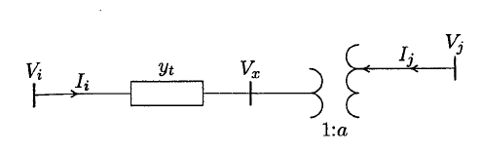
Figure 10. Tap changing transformer model.
Complex power on both sides of the ideal transformer are the same. Thus
$$V_{x}=\frac{1}{a}V_{j}$$
$$I_{i}=-a^{*}I_{j}$$
But the current on $i$ end
$$I_{i}=y_{t}\left(V_{i}-V_{x}\right)$$
$$I_{i}=y_{t}V_{i}-\frac{y_{t}}{a}V_{j}$$
Substituting for $I_{i}$
$$I_{j}=-\frac{y_{t}}{a^{*}}V_{i}+\frac{y_{t}}{{\left|a\right|}^{2}}V_{j}$$
Writing equations for $I_{i}$ and $I_{j}$ in matrix form
$$\left[\begin{matrix}I_{i} \\ I_{j}\end{matrix}\right]=\left[\begin{matrix}y_{t} & -\frac{y_{t}}{a} \\ -\frac{y_{t}}{a^{*}} & \frac{y_{t}}{{\left|a\right|}^{2}}\end{matrix}\right]\left[\begin{matrix}V_{i} \\ V_{j}\end{matrix}\right]$$
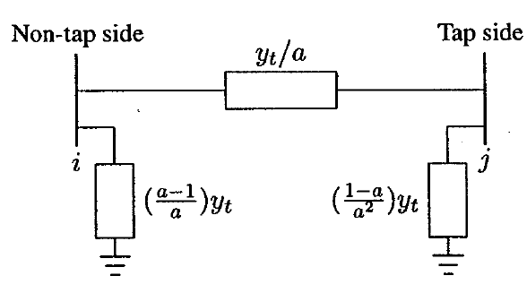
Figure 11. Tap changing transformer equivalent network

